Use Case Lab 1 – Individual activity
Select a use case from your use case table to develop. Your use case may query several objects, and must allow the instantiation of only one object.
Your use case must include:
- User Story
- UI Design (Mockup)
- Activity Diagram detailing all pathways through the use case
- Use Case Description that enables the actor to ‘add’.
- Class diagram
Copy all of your work into a single word document and submit along with all supporting files.

Use Case Table
Register for Class | Register a participant for a class | An enrolled family wants to register for a class | Parent | Registers a participant, applies fees for discounts, and records registration payment
- User Story
As a parent enrolled with ProTKD, I would like to register a participant for an available class so that the participant can attend the selected class.

- UI Design (Mockup)
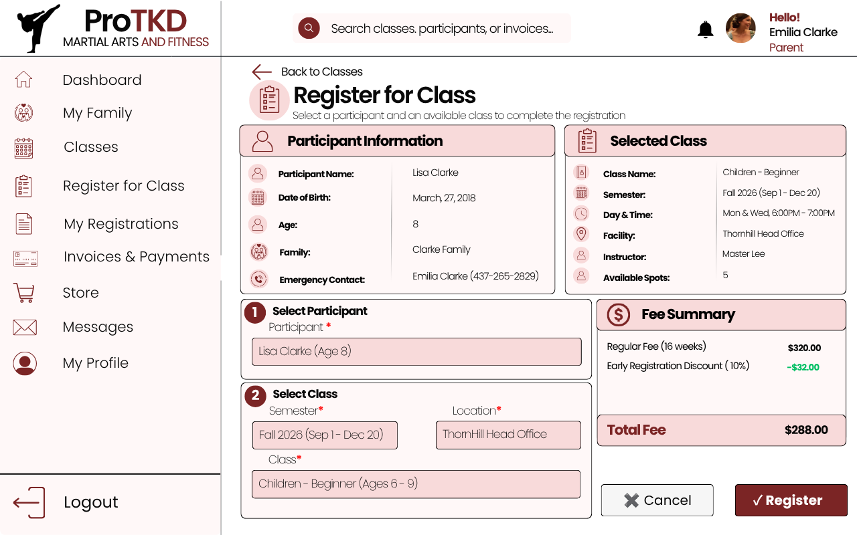
- Activity Diagram
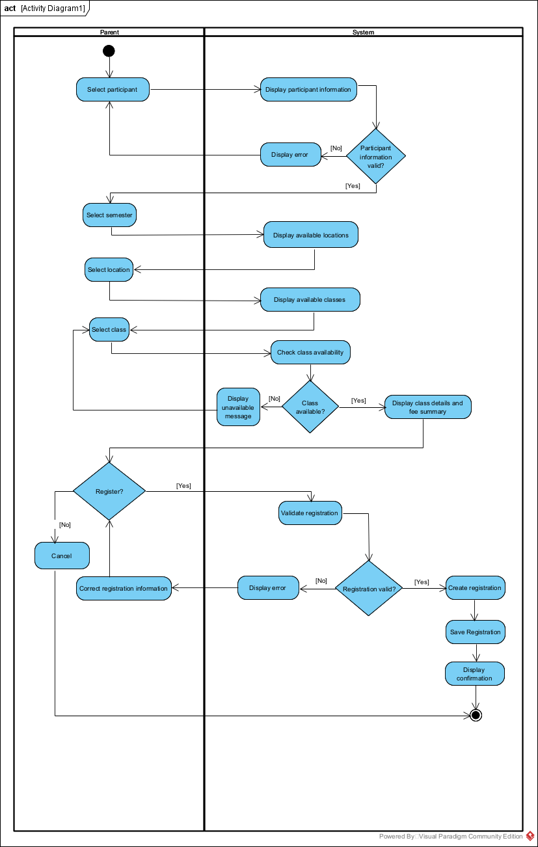
- Use Case Description that enables the actor to ‘add’
Use Case Description Name | Register for Class
Triggering Event | An enrolled parent wants to register a participant for an available class.
Brief Description | Allows a parent to select a participant and an available class and create a registration.
Actors | Parent
Related Use Cases | Enroll Family, Pay Registration Fee
Preconditions | Parent and family are enrolled with ProTKD. Participant information and emergency contact information are available.
Post Conditions | Registration is saved and can be queried.
Flow of activities | Actor |  | System
 |  | Requests to register for a class. | Displays available participants and participant information.
 |  | Selects a participant, semester, location and class. | Displays available locations and classes. Checks class availability and displays class details and fee summary.
 |  | Selects Register. | Validates the registration information.
 |  | Corrects information if required and selects Register again. | Creates and saves the registration. Displays registration confirmation.
Exception Conditions | - Parent chooses to cancel adding the registration.  - Participant information is invalid or incomplete.  - Selected class is unavailable.  - Registration information is invalid.

- Class Diagram
